**Cerner to Bridge ORM Requirements**

**Version 1.2**

**Prepared By: Levy Lazarre and Hope Kaczmarczyk**

**Date: 7/29/2019**

Document Control 3

Resources 3

Document Version Control 3

1. Introduction 4

1.1 Purpose 4

1.2 Project Scope 4

1.3 Terminology Standards 4

1.3.1 Acronyms 4

1.3.2 Glossary 4

1.4 Document References 4

2. Diagrams 5

3. Requirements 7

3.1 Functional Requirements 7

3.2 Messaging Protocols 9

3.2.1 Inbound to the BayCare Cloverleaf From Cerner 9

3.2.2 Outbound from BayCare CloverLeaf 9

4. HL7 Messaging 10

4.1 Messaging Format 10

4.1.1 Segments 10

4.1*.*2 Messaging Event Types 10

4.1*.*3 Cloverleaf Configuration Files 11

4.1.4 Cloverleaf Site Location 11

4.2 Data Transformation Requirements 11

4.3 Sample Message 15

Appendix A: Risks and Concerns 17

Appendix B: Issues List 17

# **Document Control**

## Resources

|  |  |  |
| --- | --- | --- |
| **Name** | **Role** | **Email** |
| Michael J King | IS Project Manager, BayCare | Michael.King@baycare.org |
| Andrew Miller | System Engineer,  Consulting Advancement Team, Cerner | Andrew.Miller@cerner.com |
| Matthew Awosanya | Technology Consultant, Cerner | matthew.awosanya@cerner.com |
| Michael Harris | Software Engineer, Cerner | Michael.Harris@Cerner.com |
| Nicole Gitney | Director of Nursing Informatics | Nicole.Gitney@baycare.org |
| Debra Armstrong | SR Systems Analyst,  APPS - DOCUMENTATION | Debra.Armstrong@baycare.org |
| Hope Kaczmarczyk | SR Integration Analyst, BayCare EIT | Hope.Kaczmarczyk@baycare.org |
| Levy Lazarre | Integration Analyst, Baycare EIT | Levy.Lazarre@baycare.org |
| Amy S Knight | SR Systems Analyst,  APPLICATIONS ANCILLARY | Amy.Knight@baycare.org |
| Jeff Jung | BayCare Manager Laboratory IT | [Jeffrey.Jung@BayCare.org](mailto:Jeffrey.Jung@baycare.org) |
| Jane K Holz | SR Systems Analyst,  LAB COMPUTER | Jane.Holz@baycare.org |
| Danielle Sawyer | Systems Analyst,  REVENUE CYCLE APPLICATIONS | Danielle.Sawyer@baycare.org |

## Document Version Control

|  |  |  |  |
| --- | --- | --- | --- |
| **Version** | **Date** | **Modifier** | **Description** |
| V1.0 | 01/03/2018 | Levy Lazarre | Original document |
| V1.1 | 01/10/2018 | Hope Kaczmarczyk | Added Cerner information and project diagrams |
| V2 | 7/29/19 | Art Schwartz | Update for cerner Model |
|  |  |  |  |

# 1. Introduction

## 1.1 Purpose

The purpose of this document is to describe the **ORM** (Orders) Interface going from Cerner Millennium to Cerner Bridge Solutions.

Bridge is a Cerner application used by nurses for the management and documentation of breast milk/infant feeding to newborns and blood transfusions to hospital patients.

## 1.2 Project Scope

The scope of this project is to automate the integration of the Cerner Bridge Solutions application with the Soarian HIS via HL7 ADT interface and the Cerner EMR via HL7 Orders, Results, and BTS interfaces. The current document describes the ORM interface, orders from Cerner Millennium to Bridge.

## 1.3 Terminology Standards

### 1.3.1 Acronyms

**ADT** – Admission, Discharge, Transfer: mainly demographic and patient location data

**BTS -** Blood Product Transfusion Status/Disposition

**DTA** - Discrete Task Assay; reference data item

**HIS** – Health Information System, the source and keeper of patient demographic data

**ORM** – A HL7 Order Message

### 1.3.2 Glossary

**ADT Event** – Trigger event associated with a patient event: registration, admission, discharge, transfer, update…

**Alias** - An identifier used to represent an item, such as a location, order, specimen type, or result.

**Bridge** - An external Cerner Solution used by Baycare for Medical Breast Milk/Infant Feeding Management and

Transfusion Administration.

**Contributor System –** External System that sends to and/or receives data from Cerner Millennium. A “Contributor System” is built on Cerner as part of an interface or data feed.

**Contributor Source –** A source created on Cerner used to identify inbound and/or outbound aliases for data sent to and received from Foreign Systems.

**Scripting –** Custom Cerner programs written to modify, format, and filter message transactions for the interfaces. The types of scripts used by FSI are Suppression, Route, Modify Object, Modify Original, Type, and ACK.

## 1.4 Document References

1. Cerner Bridge Solutions Interface Specifications.doc – Cerner July 1, 2016

2. BM AND BMM TESTING PATIENTS.xlsx

3. Cerner HL7 Specifications: Unit 09o – Order Message Processing Outbound – Cerner Apr 12, 2017

# 2. Diagrams

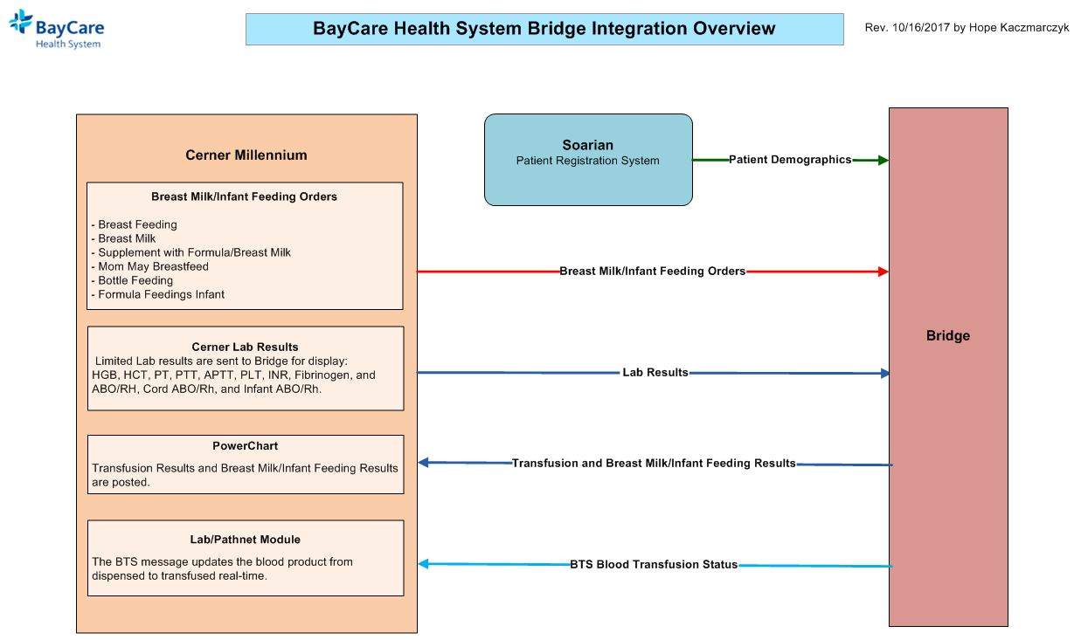

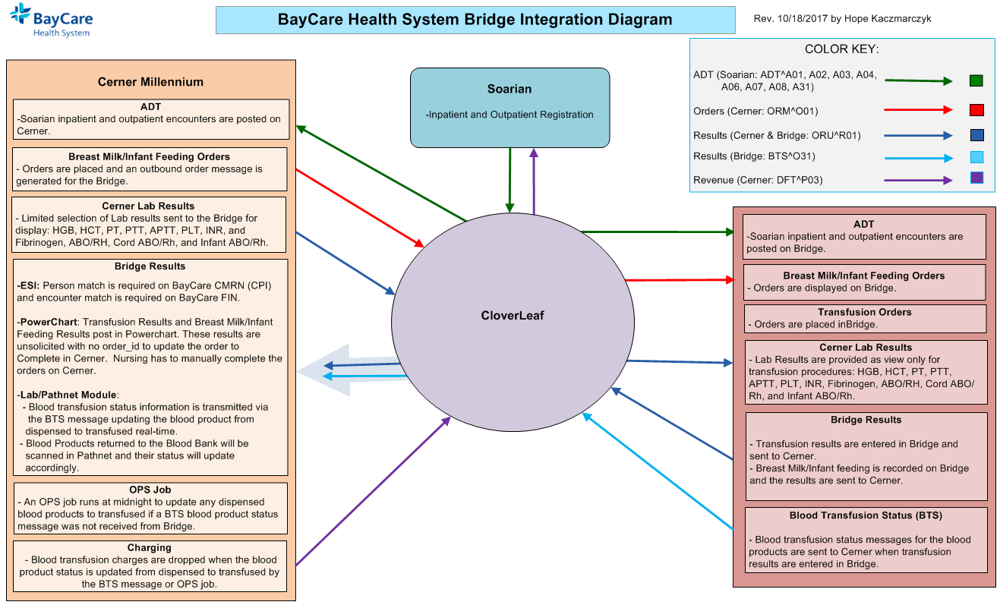

CloverLeaf Threads for BayCare Cerner Orders outbound to Bridge on CloverLeaf Site: cerner_orders_6_p:

# 3. Requirements

## 3.1 Functional Requirements

|  |  |  |
| --- | --- | --- |
| **Cloverleaf** |  |  |
| **Number** | **Requirement Name** | **Requirement Description** |
| FR.2018.1.0 | No message filter required in Cloverleaf for this interface. | The orders from Cerner Millennium are received on a dedicated connection from a dedicated line in Cerner. Only orders for Bridge are sent through, hence no filter is needed in Cloverleaf. |
| FR.2018.2.0 | Send the BayCare CPI in PID.2 | The BayCare CPI will be sent in PID.2, with an identifier type hardcoded to “CMRN”. |
| FR.2018.3.0 | Send the BayCare MRN in PID.3 | Only one identifier (MRN) may be sent in PID.3; the identifier type will be hardcoded as “MRN” |
| FR2018.4.0  FR2018.5.0 | Send the account number in  PID.18  Send “CA” for cancelled orders. | The account (FIN) number is sent in PID.18; the identifier type will be hardcoded as “FIN”.  If an order is cancelled, the interface needs to send “CA” in ORC.1. |

|  |  |  |
| --- | --- | --- |
| **Cerner** |  |  |
| **Number** | **Requirement Name** | **Requirement Description** |
| FR.2018.01.1  FR.2018.01.2  FR.2018.01.3 | New Contributor System: BRIDGE  **New Cerner Contributor Source:**  BRIDGE  **ESO Interface Trigger:**  Order Entry/ORM CORE (CQM Class: ORM_CORE) | The BRIDGE contributor system was created on Cerner to handle the breast milk/infant feeding orders and limited Lab results sent outbound along with the breast milk/infant feeding, transfusion, and blood product disposition results sent inbound.  BRIDGE is a bi-directional contributor system:  - Organization: BayCare Health System  - Contributor System Type: Unauth  - Contributor Source: BRIDGE  - Alt Contributor Source: Invision  - Message Format: HL7 Standard V2.x  - Outbound Alias Processing: CVO Decode, Use Prim/Second  Source. This means Cerner will send the alias for the contributor  source BRIDGE first and if it finds none it will send the alias for  the alt contributor source Invision.  **Outbound Field Processing**- Common MSH Processing:  - MSH-3 Sending App = HNAM  - MSH-4 Sending Facility = CERNER  - MSH-5 Receiving App = BRIDGE  - MSH-6 Receiving Facility = BAYCARE  The contributor system, Bridge, uses BayCare’s main contributor source Invision aliases for most code sets. The contributor source of BRIDGE is used for order, DTA, and result aliases that are associated with the Bridge Solution.  - All BayCare breast milk/infant feeding orders for Bridge are required to have an outbound alias assigned to the contributor source of BRIDGE in code set 200 which is mapped on Bridge Solutions.  - This trigger causes the BayCare breast milk/infant feeding order to be processed outbound when entered.  - The following segments are set to be sent outbound by this trigger:   * HL7 MSH * HL7 PID * HL7 PV1 * HL7 PV2 * HL7 IN1 * HL7 IN2 * HL7 IN3 * HL7 ORC/OBR/NTE |
| FR.2018.01.4 | Sub-Activity Types:  -**Bridge Diets** (associated with activity type CDF meaning of DIETARY)  - **Bridge Monitoring** (associated with activity type CDF meaning of ASMTTXMONITO) | All breast milk/infant feeding orders to be sent outbound to Bridge require a Sub-Activity type which has a unique CDF meaning of BRIDGE. The CDF meaning of the Sub-Activity type has to be BRIDGE, otherwise, the orders could be suppressed by the global ESO Orders Suppression script or not routed to the proper comserver, ORM_TCP_BRIDGE_OUT. (Note: Code set 5801 Activity Sub Type) |
| FR.2018.01.5 | Global Scripts:  - ESO Suppression Script: eso_get_order_selection  .prg  - route_out | Addition made to the eso_get_order_selection script to un-suppress all orders with a sub-activity type having the CDF meaning of BRIDGE.  - route_out (global script): Logic to route BayCare breast milk/infant feeding orders for BRIDGE to the ORM_TCP_BRIDGE_OUT comserver. Logic is based on:   * Message Type = ORM * CQMSUBTYPE (Activity Type CDF Meaning) = DIETARY with Sub-Activity Type of BRIDGE * ACTIVITY_SUBTYPE_CDM = Sub-Activity Type of BRIDGE |
| FR.2018.01.6 | New ComServer:  ORM_TCP_BRIDGE_OUT  With Mod Object script: orm_bridge_out | orm_bridge_out script for breast milk/infant feeding orders  outbound to Bridge. Mod Object Script:   * calls the generic mod object script, MSH_FAC_MODOBJ_OUT, to populate MSH.5 (Receiving Application) with the facility from PV1.3.4.1 (e.g., SJW) * Removes extra fields from PV1.19 * Blanks out SSN if “999999999” * will change a message type of SN to NW in ORC.2. |

## 3.2 Messaging Protocols

Below are listed the details for the messaging protocols that will be leveraged for this integration. Please see the reference document located on the Integration SharePoint server.

### 3.2.1 Inbound to the BayCare Cloverleaf From Cerner

* TCP MLLP Server Connection
  + HL7 2.3 ORM messages from BayCare Cerner to BayCare Cloverleaf

### 3.2.2 Outbound from BayCare CloverLeaf

* TCP MLLP Client Connection
  + HL7 2.3 ORM messages to Bridge.
  + HL7 2.3 Acknowledgment Messages returned from CloverLeaf to BayCare Cerner.

# 4. HL7 Messaging

## 4.1 Messaging Format

### 4.1.1 Segments

The segments utilized for this interface are:

MSH

PID

PV1

PV2*

ORC

OBR

{OBX}

{NTE}

*Message Construction Notes:*

*[Square Brackets] – Optional*

*{Curly Brackets} – Repeatable*

*MSH – Message Header*

*PID – Patient ID segment*

*PV1 – Patient Visit segment*

*PV2 – Additional Patient Visit segment * Removed by CloverLeaf*

*ORC – Common Order segment*

*OBR – Observation request segment*

*OBX – Observation/Result segment*

*NTE – Note Segment*

### 4.1*.*2 Messaging Event Types

Below are the messages types necessary for this integration

Supported ORM Events

|  |  |
| --- | --- |
| **Event Type** | **Description** |
| O01 | Transmission of a BayCare order to Bridge. |
| ACK | Standard Acknowledgment messages |

### 4.1*.*3 Cloverleaf Configuration Files

For each HL7 interface specified in Section 2 of this document, identify the Cloverleaf Configuration Files: Variants, TCL Scripts, Xlates, etc.

HL7 Variants: 2.3 cerner_emr

Xlate: cerner_bridge_orm_bm.xlt

### 4.1.4 Cloverleaf Site Location

Production = cerner_orders_6_p

Test = cerner_orders_6

## 4.2 Data Transformation Requirements

| **Field Description** | **HL7 Field Loc.** | **Required R/O/C** | **Data Type** | **Length** | **Notes** |
| --- | --- | --- | --- | --- | --- |
| **Message Header Segment** | **MSH** | R |  |  | CloverLeaf: PathCopy |
| Sending Application | MSH.3 | C |  |  | Cerner sends “HNAM”.  CloverLeaf: hardcode of “HNAM”. |
| Sending Facility | MSH.4 | R |  |  | Cerner sends “CERNER”.  CloverLeaf copies inbound MSH.5 to this field. |
| Receiving Application | MSH.5 | O |  |  | Cerner’s MSH_FAC_MODOBJ_OUT script populates **this field** with the facility from PV1.3.4.1 .  CloverLeaf copies this field to MSH.4 and MSH.6. Then, replaces with a hardcode of “BRIDGE”. |
| Receiving Facility | MSH.6 | R |  |  | Cerner sends “BAYCARE”.  CloverLeaf copies inbound MSH.5 to this field. |
| **Patient Identifier Segment** | **PID** | R |  |  |  |
| Patient ID (External) | PID.2 | R |  |  | CloverLeaf copy of the CMRN from PID.3 with the Identifier Type of “CMRN” |
| Patient ID (Internal) | PID.3 | R |  |  | CloverLeaf copy of the MRN from PID.3 with the Identifier Type Code of “MRN” |
| Patient Name | PID.5 | R |  |  | CloverLeaf copy of Patient’s Last Name, First Name, Middle Name, Suffix, Prefix, Name Type Code |
| Date of Birth | PID.7 | R |  |  | CloverLeaf: Copy |
| Gender | PID.8 | R |  |  | CloverLeaf: Copy |
| Race | PID.10 | O |  |  | CloverLeaf: Copy |
| Patient Account Number | PID.18 | R |  |  | Copy (first component of PID.18) with Identifier Type Code of “FIN” |
| SSN | PID.19 | O |  |  | Cerner orm_bridge_out script will blank out this field when populated with “999999999”.  CloverLeaf: Copy |
| **Patient Visit Segment** | **PV1** | R |  |  |  |
| Patient Class | PV1.2 | O |  |  | CloverLeaf: Copy |
| Assigned Patient Location | PV1.3 | R |  |  | CloverLeaf: PathCopy |
| Admission Type | PV1.4 | O |  |  | CloverLeaf: Copy |
| Prior Patient Location | PV1.6 | O |  |  | CloverLeaf: Copy |
| Attending Doctor | PV1.7 | O |  |  | CloverLeaf: Copy ID Number, Family Name, Given Name, Second Names or Initials. If necessary, left pad the ID with zeros to a length of 5. |
| Consulting Doctor | PV1.9 | O |  |  | CloverLeaf: Copy ID Number, Family Name, Given Name, Second Names or Initials. If necessary, left pad the ID with zeros to a length of 5. |
| Hospital Service | PV1.10 | O |  |  | CloverLeaf: Copy |
| VIP Indicator | PV1.16 | O |  |  | CloverLeaf: Copy |
| Admitting Doctor | PV1.17 | O |  |  | CloverLeaf: Copy ID Number, Family Name, Given Name, Second Names or Initials. If necessary, left pad the ID with zeros to a length of 5. |
| Patient Type | PV1.18 | O |  |  | CloverLeaf: Copy |
| Admit Date/Time | PV1.44 | R |  |  | CloverLeaf: Copy |
| Discharge Date/Time | PV1.45 | O |  |  | CloverLeaf: Copy |
| **Common Order Segment** | **ORC** | R |  |  |  |
| Order Control | ORC.1 | R |  |  | Cerner orm_bridge_out script will replace this filed with “NW” when populated with “SN”.  CloverLeaf: Copy “**NW**” to this field. However, if ORC.5 = 77 (indicating a cancel order from Cerner), copy “**CA**” instead. |
| Placer Order Number | ORC.2 | RO |  |  | CloverLeaf: Copy |
| Order Status | ORC.5 | RO |  |  | CloverLeaf: Copy. The length of this field in the HL7 variant must be long enough to receive strings like “Ordered” from Cerner. |
| Date/Time of Transaction | ORC.9 | RO |  |  | CloverLeaf: Copy |
| Entered By | ORC.10 | RO |  |  | CloverLeaf: Copy |
| Ordering Provider | ORC.12 | RO |  |  | CloverLeaf: Copy ID Number, Family Name, Given Name, Second Names or Initials. If necessary, left pad the ID with zeros to a length of 5. |
| Enterer’s Location | ORC.13 | O |  |  | CloverLeaf: Copy |
| Order Effective Date/Time | ORC.15 | RO |  |  | CloverLeaf: Copy |
| Order Control Code Reason | ORC.16 | O |  |  | CloverLeaf: Copy |
| Entering Device | ORC.18 | O |  |  | CloverLeaf: Copy |
| Action By | ORC.19 | O |  |  | CloverLeaf: Copy |
| **Observation Request Segment** | **OBR** | R |  |  |  |
| Set ID - OBR | OBR.1 | RO |  |  | CloverLeaf: Copy |
| Placer Order Number | OBR.2 | RO |  |  | CloverLeaf: Copy |
| Filler Order Number | OBR.3 | O |  |  | CloverLeaf: Copy |
| Universal Service Identifier | OBR.4 | R |  |  | CloverLeaf: Copy |
| Requested Date/Time | OBR.6 | R |  |  | CloverLeaf: Copy inbound OBR.22 |
| Observation Date/Time | OBR.7 | O |  |  | CloverLeaf: Copy |
| Observation End Date/Time | OBR.8 | O |  |  | CloverLeaf: Copy |
| Ordering Provider | OBR.16 | RO |  |  | CloverLeaf: Copy ID Number, Family Name, Given Name, Second Names or Initials. If necessary, left pad the ID with zeros to a length of 5. |
| Placer Field 1 | OBR.18 | O |  |  | CloverLeaf: Copy |
| Placer Field 2 | OBR.19 | O |  |  | CloverLeaf: Copy |
| Filler Field 1 | OBR.20 | O |  |  | CloverLeaf: Copy |
| Filler Field 2 | OBR.21 | O |  |  | CloverLeaf: Copy |
| Results Rpt/Status Chng- Date/Time | OBR.22 | R |  |  | CloverLeaf: Copy |
| Charge To Practice | OBR.23 | O |  |  | CloverLeaf: Copy |
| Diagnostic Serv Sect ID | OBR.24 | O |  |  | CloverLeaf: Copy |
| Quantity/Timing | OBR.27 | R |  |  | CloverLeaf: Copy |
| **Observation (OBX) and Note (NTE) Segments** | **OBX / NTE** | O |  |  | **ITERATE over the group. For each OBX or NTE:** |
| Set ID - OBX | OBX.1 | O |  |  | CloverLeaf: Copy |
| Value Type | OBX.2 | R |  |  | CloverLeaf: Copy |
| Observation Identifier | OBX.3 | R |  |  | CloverLeaf: Copy |
| Observation Sub-ID | OBX.4 | O |  |  | CloverLeaf: Copy |
| Observation Value | OBX.5 | O |  |  | CloverLeaf: Copy |
| NTE segment | NTE | O |  |  | CloverLeaf: PathCopy the whole segment |

## 4.3 Sample Message

Inbound to Cloverleaf from Cerner:

MSH|^~\&|HNAM|CERNER|SJW|BAYCARE|20171229181957||ORM^O01|Q3716399671T4756347271||2.3||||||8859/1

PID|1|7000016261^^^BayCare MRN^MRN^SOARIAN|7000016261^^^BayCare MRN^MRN^SOARIAN~810015446^^^BayCare CMRN^Community Medical Record Number^SOARIAN|810015446^^^BayCare EAD CPI^Historical CMRN^SOARIAN|BRIDGEMED^ONE-BABYGIRL||20170921142300|F||U|123 CHERRY LANE^^Clearwater^FL^33759^^Home|||||S|LDS|6000034990^^^BayCare FIN||||UNK|||1

PV1|1|I|W4NB^4257^02^SJW^^Bed(s)^SJW|N|||ME98456^Mxqrf^Mymza^X^^^^^Doctor License Number^Personnel^^^LICENSENBR^CACTUS~FS0313104^Mxqrf^Mymza^X^^^^^DEA No^Personnel^^^DOCDEA^CACTUS~MS061690^Mxqrf^Mymza^X^^^^^Username^Personnel^^^Username^CACTUS~1093920969^Mxqrf^Mymza^X^^^^^NPI Number^Personnel^^^National Provider Identifier^CACTUS~80307^Mxqrf^Mymza^X^^^^^SJH^Personnel^^^ORGANIZATION DOCTOR^CACTUS~80307^Mxqrf^Mymza^X^^^^^SJW^Personnel^^^ORGANIZATION DOCTOR^CACTUS~80307^Mxqrf^Mymza^X^^^^^MCS^Personnel^^^ORGANIZATION DOCTOR^CACTUS~80307^Mxqrf^Mymza^X^^^^^MDU^Personnel^^^ORGANIZATION DOCTOR^CACTUS~80307^Mxqrf^Mymza^X^^^^^MPH^Personnel^^^ORGANIZATION DOCTOR^CACTUS~80307^Mxqrf^Mymza^X^^^^^NBY^Personnel^^^ORGANIZATION DOCTOR^CACTUS~80307^Mxqrf^Mymza^X^^^^^SFB^Personnel^^^ORGANIZATION DOCTOR^CACTUS~80307^Mxqrf^Mymza^X^^^^^SAH^Personnel^^^ORGANIZATION DOCTOR^CACTUS~80307^Mxqrf^Mymza^X^^^^^SJN^Personnel^^^ORGANIZATION DOCTOR^CACTUS~MS061690^Mxqrf^Mymza^X^^^^^BayCare Dr Number^Personnel^^^ORGANIZATION DOCTOR^CACTUS~061690^Mxqrf^Mymza^X^^^^^WHH^Personnel^^^ORGANIZATION DOCTOR^CACTUS~061690^Mxqrf^Mymza^X^^^^^WHW^Personnel^^^ORGANIZATION DOCTOR^CACTUS~80307^Mxqrf^Mymza^X^^^^^SJS^Personnel^^^ORGANIZATION DOCTOR^CACTUS~OTH000^Mxqrf^Mymza^X^^^^^UPIN^Personnel^^^DOCUPIN^CACTUS~6251113117014^Mxqrf^Mymza^X^^^^^SureScripts Prescriber ID^Personnel^^^SureScripts Prescriber Index|||NSY||||CD:938038807||N||I|||||||||||||||||||||SJW||Active|||20170921142300

PV2||B|^BRIDGE MED TEST NEWBORN|||||||0||||||||||||CONFID|^^589750

ORC|NW|11782724315^HNAM_ORDERID|||Ordered||||20170921161613|DAA47136^Armstrong^Debra^A^^^^^External Id^Personnel^^^External Identifier||11016^Held^Jeffrey^A^^^^^MCS^Personnel^^^ORGANIZATION DOCTOR^CACTUS~11016^Held^Jeffrey^A^^^^^MDU^Personnel^^^ORGANIZATION DOCTOR^CACTUS~11016^Held^Jeffrey^A^^^^^MPH^Personnel^^^ORGANIZATION DOCTOR^CACTUS~11016^Held^Jeffrey^A^^^^^NBY^Personnel^^^ORGANIZATION DOCTOR^CACTUS~H53198^Held^Jeffrey^A^^^^^UPIN^Personnel^^^DOCUPIN^CACTUS~34330^Held^Jeffrey^A^^^^^External Id^Personnel^^^External Identifier~79348^Held^Jeffrey^A^^^^^SJH^Personnel^^^ORGANIZATION DOCTOR^CACTUS~79348^Held^Jeffrey^A^^^^^SJW^Personnel^^^ORGANIZATION DOCTOR^CACTUS~5299^Held^Jeffrey^A^^^^^SAH^Personnel^^^ORGANIZATION DOCTOR^CACTUS~ME90446^Held^Jeffrey^A^^^^^Doctor License Number^Personnel^^^LICENSENBR^CACTUS~1841243557^Held^Jeffrey^A^^^^^NPI Number^Personnel^^^National Provider Identifier^CACTUS~BH7487108^Held^Jeffrey^A^^^^^DEA No^Personnel^^^DOCDEA^CACTUS~79348^Held^Jeffrey^A^^^^^SJN^Personnel^^^ORGANIZATION DOCTOR^CACTUS~5299^Held^Jeffrey^A^^^^^SFB^Personnel^^^ORGANIZATION DOCTOR^CACTUS~D11016^Held^Jeffrey^A^^^^^Username^Personnel^^^Username~6321100102002^Held^Jeffrey^A^^^^^SureScripts Prescriber ID^Personnel^^^SureScripts Prescriber Index~MS009852^Held^Jeffrey^A^^^^^Username^Personnel^^^Username^CACTUS~MS009852^Held^Jeffrey^A^^^^^BayCare Dr Number^Personnel^^^ORGANIZATION DOCTOR^CACTUS|||20171229181954|||Written^Written/Paper/Fax|DAA47136^Armstrong^Debra^A^^^^^External Id^Personnel^^^External Identifier

OBR|1|11782724315^HNAM_ORDERID||Formula Feedings Infant^Formula Feedings Infant||||||||||||11016^Held^Jeffrey^A^^^^^MCS^Personnel^^^ORGANIZATION DOCTOR^CACTUS~11016^Held^Jeffrey^A^^^^^MDU^Personnel^^^ORGANIZATION DOCTOR^CACTUS~11016^Held^Jeffrey^A^^^^^MPH^Personnel^^^ORGANIZATION DOCTOR^CACTUS~11016^Held^Jeffrey^A^^^^^NBY^Personnel^^^ORGANIZATION DOCTOR^CACTUS~H53198^Held^Jeffrey^A^^^^^UPIN^Personnel^^^DOCUPIN^CACTUS~34330^Held^Jeffrey^A^^^^^External Id^Personnel^^^External Identifier~79348^Held^Jeffrey^A^^^^^SJH^Personnel^^^ORGANIZATION DOCTOR^CACTUS~79348^Held^Jeffrey^A^^^^^SJW^Personnel^^^ORGANIZATION DOCTOR^CACTUS~5299^Held^Jeffrey^A^^^^^SAH^Personnel^^^ORGANIZATION DOCTOR^CACTUS~ME90446^Held^Jeffrey^A^^^^^Doctor License Number^Personnel^^^LICENSENBR^CACTUS~1841243557^Held^Jeffrey^A^^^^^NPI Number^Personnel^^^National Provider Identifier^CACTUS~BH7487108^Held^Jeffrey^A^^^^^DEA No^Personnel^^^DOCDEA^CACTUS~79348^Held^Jeffrey^A^^^^^SJN^Personnel^^^ORGANIZATION DOCTOR^CACTUS~5299^Held^Jeffrey^A^^^^^SFB^Personnel^^^ORGANIZATION DOCTOR^CACTUS~D11016^Held^Jeffrey^A^^^^^Username^Personnel^^^Username~6321100102002^Held^Jeffrey^A^^^^^SureScripts Prescriber ID^Personnel^^^SureScripts Prescriber Index~MS009852^Held^Jeffrey^A^^^^^Username^Personnel^^^Username^CACTUS~MS009852^Held^Jeffrey^A^^^^^BayCare Dr Number^Personnel^^^ORGANIZATION DOCTOR^CACTUS||||||20171229181954||Diets|||1^^0^20171230070000

OBX|1|ST|Volume^Volume||140 ml/kg/day

OBX|2|IS|Peds Formula Additives^Peds Formula Additives||Similac Human Milk Fortifier

OBX|3|IS|Peds Formula Calories^Peds Formula Calories||21 KCAL

OBX|4|IS|Peds Formula Type^Peds Formula Type||Powder

OBX|5|IS|Peds Formula^Peds Formula||Similac Advance

OBX|6|IS|Feeding Route^Feeding Route||PO

OBX|7|ST|Peds Formula Additive Amount^Peds Formula Additive Amount||6 cal Neosure Powder

OBX|8|IS|Human Milk Type^Human Milk Type||Moms Expressed Breast Milk

Outbound from Cloverleaf to Bridge:

MSH|^~\&|HNAM|SJW|BRIDGE|SJW|20171229181957||ORM^O01|Q3716399671T47563472|P|2.3||||||8859/1

PID||810015446^^^BCHS^CMRN|7000016261^^^BCHS^MRN||BRIDGEMED^ONE-BABYGIRL||20170921142300|F||U||||||||6000034990^^^BCHS^FIN

PV1||I|W4NB^4257^02^SJW^^Bed(s)^SJW|N|||80307^Mxqrf^Mymza^X|||NSY||||||N||I||||||||||||||||||||||||||20170921142300

ORC|NW|11782724315^HNAM_ORDERID|||Ordered||||20170921161613|DAA47136^Armstrong^Debra^A^^^^^External Id^Personnel^^^External Identifier||79348^Held^Jeffrey^A|||20171229181954|||Written^Written/Paper/Fax|DAA47136^Armstrong^Debra^A^^^^^External Id^Personnel^^^External Identifier

OBR|1|11782724315^HNAM_ORDERID||Formula Feedings Infant^Formula Feedings Infant||20171229181954||||||||||79348^Held^Jeffrey^A||||||20171229181954||Diets|||1^^0^20171230070000

OBX|1|ST|Volume^Volume||140 ml/kg/day

OBX|2|IS|Peds Formula Additives^Peds Formula Additives||Similac Human Milk Fortifier

OBX|3|IS|Peds Formula Calories^Peds Formula Calories||21 KCAL

OBX|4|IS|Peds Formula Type^Peds Formula Type||Powder

OBX|5|IS|Peds Formula^Peds Formula||Similac Advance

OBX|6|IS|Feeding Route^Feeding Route||PO

OBX|7|ST|Peds Formula Additive Amount^Peds Formula Additive Amount||6 cal Neosure Powder

OBX|8|IS|Human Milk Type^Human Milk Type||Moms Expressed Breast Milk

**Go Live Date for Bridge ORM interface: January 16, 2018**

# Appendix A: Risks and Concerns

|  |  |  |  |  |  |  |  |  |  |
| --- | --- | --- | --- | --- | --- | --- | --- | --- | --- |
| **Project Name** |  | |  | | |  |  |  |  |
| **Number** | **Risk / Concern** | | **Comment** | **Mitigation** | | |  |  |  |
| RC.2018.1.0 | DC’d, Cancelled, and Deleted ORM messages are sent as Completed. | The Nursing Team appoved this functionality. If DC’d, Cancelled, and Deleted are received on Bridge, they will post with the patient’s active orders. By sending them as Completed, they are removed from the Active Orders List on Bridge. | | | Tested in c30 and approved for go-live. | |  |  |  |

# Appendix B: Issues List

This is a dynamic list of the open issues related to the IDBB that remain to be solved, including but not limited to TBDs, pending decisions, information needed, conflict awaiting resolution, and the like.

|  |  |  |  |  |  |  |  |  |  |
| --- | --- | --- | --- | --- | --- | --- | --- | --- | --- |
| **Project Name** |  |  | | | |  |  |  |  |
| **Number** | **Issue** | **Comment** | | **Fix** | | |  |  |  |
| IL.2018.1.0 | No Issues to report at this time. | |  | |  | |  |  |  |

* End of document